**Bug Report - Juice Shop:**

**Bug #1:**

* **Title:** Inconsistent and Excessive Bottom Padding on Home Page Item Cards
* **Severity:** Minor
* **Description:** The bottom padding on the Home page Item Cards is inconsistent and excessive, leading to uneven spacing and an overall visually unappealing layout.
* **Steps to Reproduce:**
  1. Navigate to the Home page of the application.
  2. Observe the spacing between the Item Cards and the bottom of the viewport.
  3. Compare the spacing between different Item Cards.
* **Expected Behavior:** Consistent and appropriate bottom padding for all Item Cards, maintaining a visually balanced and professional appearance.
* **Actual Behavior:** Inconsistent and excessive bottom padding between Item Cards.

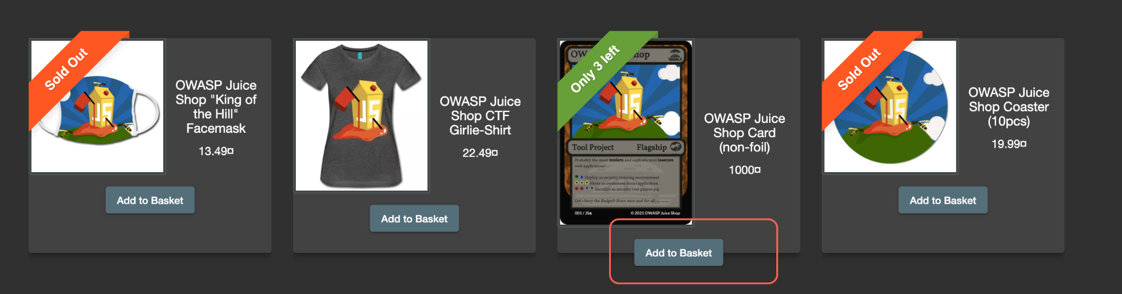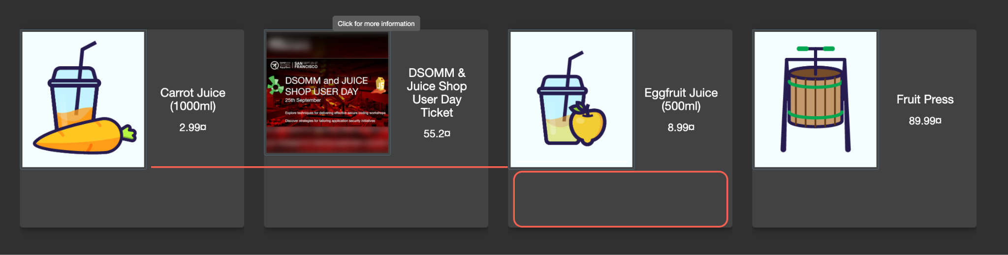

**Bug #2:**

* **Title:** Invalid Email Format Accepted in Registration Field
* **Severity:** Medium
* **Description:** The Email field in the Registration form accepts invalid email formats, such as "testuser@t," which lacks a valid domain.
* **Steps to Reproduce:**
  1. Navigate to the Registration page.
  2. Enter an invalid email address (e.g., "testuser@t") in the Email field.
  3. Attempt to proceed with registration.
* **Expected Behavior:** The system should prevent the user from proceeding and display an error message indicating that the entered email address is invalid.
* **Actual Behavior:** The system allows the user to proceed with registration using an invalid email address.

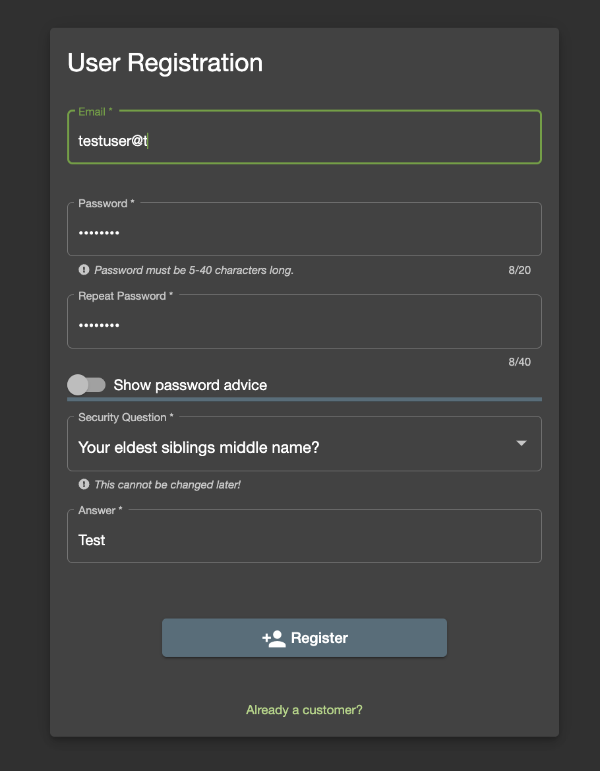

**Bug #3:**

* **Title:** Password Mismatch Validation Issue in Registration
* **Severity:** Medium
* **Description:** The Registration form allows the user to proceed even when the entered Password and Repeat Password do not match.
* **Steps to Reproduce:**
  1. Navigate to the Registration page.
  2. Enter a password (e.g., "Test@123") in the Password field.
  3. Enter a different password (e.g., "Test@124") in the Repeat Password field.
  4. Attempt to proceed with registration.
* **Expected Behavior:** The system should display an error message indicating that the passwords do not match and prevent the user from proceeding.
* **Actual Behavior:** The system allows the user to proceed with registration despite the password mismatch.

**Bug #4:**

* **Title:** "-" Button for Reducing Quantity Inoperable When Quantity is 1
* **Severity:** Minor
* **Description:** The "-" button to reduce the order quantity in the Basket is enabled even when the quantity is 1, but it does not function as expected.
* **Steps to Reproduce:**
  1. Add a product to the Basket.
  2. Reduce the quantity to 1 using the "-" button.
  3. Attempt to click the "-" button again.
* **Expected Behavior:** The "-" button should be disabled or hidden when the quantity is 1, preventing the user from reducing the quantity below 1.
* **Actual Behavior:** The "-" button is enabled but does not decrease the quantity when clicked.

**Bug #5:**

* **Title:** Basket Count Badge Resets to 0 on Page Refresh
* **Severity:** Minor
* **Description:** The Basket count badge on the navigation bar resets to 0 after a page refresh, even if items are present in the basket.
* **Steps to Reproduce:**
  1. Add one or more products to the Basket.
  2. Observe the Basket count badge on the navigation bar.
  3. Refresh the page.
* **Expected Behavior:** The Basket count badge should retain the correct number of items in the basket after a page refresh.
* **Actual Behavior:** The Basket count badge resets to 0 after a page refresh.

**Bug #6:**

* **Title:** No Confirmation Dialog Before Deleting Product from Basket
* **Severity:** Minor
* **Description:** The system allows users to delete products from the Basket without any confirmation dialog, increasing the risk of accidental deletions.
* **Steps to Reproduce:**
  1. Add a product to the Basket.
  2. Click the "Delete" button for the product in the Basket.
* **Expected Behavior:** The system should display a confirmation dialog before deleting the product, allowing the user to confirm the action.
* **Actual Behavior:** The product is deleted from the Basket without any confirmation.

**Bug #7:**

* **Title:** "Add to Basket" Button Overlaps Item Card on Home Page
* **Severity:** Minor
* **Description:** When the image within an Item Card on the Home page is longer than the card's width, the "Add to Basket" button overlaps the card, making it difficult to click.
* **Steps to Reproduce:**
  1. Navigate to the Home page.
  2. Find an Item Card with a long image.
  3. Observe the position of the "Add to Basket" button.
* **Expected Behavior:** The "Add to Basket" button should be properly positioned within the Item Card, even for items with longer images.
* **Actual Behavior:** The "Add to Basket" button overlaps the image, making it difficult or impossible to click.



**Bug #8:**

* **Title:** "Add to Basket" Button Visible for Sold Out Items
* **Severity:** Minor
* **Description:** The "Add to Basket" button is visible for items that are marked as "Sold Out," which can be confusing and misleading for users.
* **Steps to Reproduce:**
  1. Navigate to the Home page.
  2. Find an item that is marked as "Sold Out."
  3. Observe the "Add to Basket" button.
* **Expected Behavior:** The "Add to Basket" button should be disabled or hidden for items that are marked as "Sold Out."
* **Actual Behavior:** The "Add to Basket" button is visible for "Sold Out" items.

**Bug #9:**

* **Title:** User Session Persists on UI but Actions are Not Reflected
* **Severity:** Medium
* **Description:** The user session appears to be maintained on the user interface (e.g., user is logged in), but actions that require a valid session (such as adding items to the basket, viewing the basket) do not function as expected.
* **Steps to Reproduce:**
  1. Log in to the application.
  2. Add an item to the Basket.
  3. Leave the application for sometime for the session to expire. (Do not logout)
  4. Log in to the application.
  5. Try adding an item to the Basket.
  6. Refresh the page or navigate to another page.
  7. Attempt to view the Basket or perform other actions that require a valid session.
* **Expected Behavior:** The application should recognize the user session and allow the user to perform actions that require a valid session.
* **Actual Behavior:** The application may not recognize the user session, resulting in errors or unexpected behavior.